Please check all that apply

- I would like to purchase a flowering crab tree in memory of __________________________
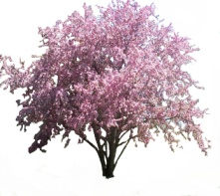
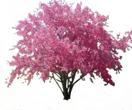

Flowering crab trees have rose red buds that open to pink flowers in spring and reddish green foliage that turns purple in fall.

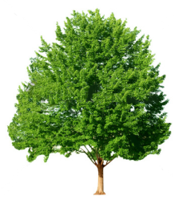
- I would like to purchase a silver maple tree in memory of ____________________________
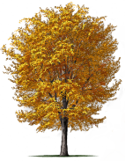

Silver maple trees are hardy and fast-growing. They have beautiful yellow-orange foliage in the fall.

- I would like to volunteer to help the Beautification Committee with planting, watering or weeding (you will be contacted by a committee member)

- I would like to make a cash donation to the Red Rock Beautification Committee and receive a tax receipt (please make cheques payable to the Township of Red Rock)
Name: ___________________________ Phone Number: _________________
Email: ___________________________

Please forward your request to the:

Township of Red Rock Beautification Committee
42 Salls Street
PO Box 447
Red Rock Ontario
P0T 2P0

Beautification Committee Member Contacts:
Judith Sobush: 807-886-2352 samsobush@hotmail.com
Sara Park: 807-886-2392 sarapark@shaw.ca

